Supplementary Materials
Title: Global Rainfall Erosivity Under Climate Change: A Systematic Review and Meta-Analysis of Trends, Uncertainty, and Data Gaps

Supplementary Material S1: Complete Boolean Search Strings and Database-Specific Search Modifications
Search execution date: 15 January 2025 (extended through January 2026)
Databases searched: Web of Science (Core Collection), Scopus, Google Scholar
Publication period covered: January 2001 – December 2025
Language restriction: English only (see S1.5 for language bias acknowledgment

S1.1 — Web of Science (Core Collection)
Primary Boolean String:
text
TS=("rainfall erosivity" OR "R-factor" OR "EI30" OR "rain erosivity")
AND TS=("climate change" OR "global warming" OR "precipitation change"
OR "emission scenario" OR "RCP" OR "SSP" OR "CMIP")
AND TS=("trend" OR "projection" OR "future" OR "historical" OR "change")
Secondary String A — Regional Qualifiers:
text
TS=("rainfall erosivity" OR "R-factor" OR "EI30")
AND TS=("South Asia" OR "Sub-Saharan Africa" OR "South America"
OR "Southeast Asia" OR "Mediterranean" OR "Loess Plateau"
OR "East Africa" OR "Central America" OR "Himalaya")
Secondary String B — Methodological Terms:
text
TS=("rainfall erosivity" OR "R-factor" OR "EI30")
AND TS=("RUSLE" OR "CHIRPS" OR "GloREDa" OR "bias correction"
OR "downscaling" OR "GPM-IMERG" OR "TRMM" OR "quantile mapping"
OR "machine learning" OR "random forest" OR "deep learning")
Filters applied:
- Document type: Article, Review Article
- Publication years: 2001–2025
- Language: English
- Citation index: SCI-Expanded, SSCI, ESCI
S1.2 — Scopus
Primary Boolean String:
text
TITLE-ABS-KEY("rainfall erosivity" OR "R-factor" OR "EI30" OR "rain erosivity")
AND TITLE-ABS-KEY("climate change" OR "global warming" OR "precipitation change"
OR "emission scenario" OR "RCP" OR "SSP" OR "CMIP")
AND TITLE-ABS-KEY("trend" OR "projection" OR "future" OR "historical" OR "change")
Secondary String A — Regional Qualifiers:
text
TITLE-ABS-KEY("rainfall erosivity" OR "R-factor" OR "EI30")
AND TITLE-ABS-KEY("South Asia" OR "Sub-Saharan Africa" OR "South America"
OR "Southeast Asia" OR "Mediterranean" OR "Loess Plateau"
OR "East Africa" OR "Central America" OR "Himalaya")
Secondary String B — Methodological Terms:
text
TITLE-ABS-KEY("rainfall erosivity" OR "R-factor" OR "EI30")
AND TITLE-ABS-KEY("RUSLE" OR "CHIRPS" OR "GloREDa" OR "bias correction"
OR "downscaling" OR "GPM-IMERG" OR "TRMM" OR "quantile mapping"
OR "machine learning" OR "random forest")

Filters applied:
- Document type: Article, Review
- Publication years: 2001–2025
- Language: English
- Subject area: Environmental Science, Earth and Planetary Sciences, Agricultural and Biological Sciences

S1.3 — Google Scholar
Note: Google Scholar does not support field-specific Boolean syntax. Searches were conducted using keyword combinations in the standard search interface. The first 200 pages (~2,000 results) per query string were screened.
Primary Query:
text
"rainfall erosivity" OR "R-factor" OR "EI30"
"climate change" OR "global warming" OR "precipitation change"
trend OR projection OR future
Regional Supplementary Queries (run separately):
text
"rainfall erosivity" "South Asia" climate change trend
"rainfall erosivity" "Sub-Saharan Africa" climate change
"rainfall erosivity" "South America" climate change projection
"R-factor" "Southeast Asia" CMIP trend
"EI30" "East Africa" rainfall trend
"rainfall erosivity" "Central America" climate
"R-factor" "Himalaya" OR "Bangladesh" OR "India" monsoon
Methodological Supplementary Queries:
text
"rainfall erosivity" RUSLE "bias correction" climate projection
"EI30" "GPM-IMERG" OR "TRMM" OR "CHIRPS" trend
"R-factor" GloREDa "climate change"
"rainfall erosivity" "machine learning" OR "random forest" trend
"R-factor" CMIP6 SSP projection soil erosion

S1.4 — Search Refinement and Pilot Rounds
The search strategy was iteratively refined through three pilot rounds applied to a randomly selected subset of 50 known-relevant studies before full deployment.
Pilot Round | Action Taken | Recovery Rate | Modification Made
Round 1 | Applied primary string only to 50 known studies | 43/50 (86%) | Added "rain erosivity" as additional erosivity term; added "CMIP" to climate terms
Round 2 | Added regional qualifier strings | 48/50 (96%) | Added "Himalaya", "East Africa", "Central America" to regional terms
Round 3 | Added methodological supplement strings | 50/50 (100%) | Confirmed final string; no further modification required
Forward and backward citation tracing was additionally conducted for all 236 retained studies and for three methodologically relevant prior reviews (Nearing et al., 2004; Borrelli et al., 2020; Panagos et al., 2017).
S1.5 — Language Bias Acknowledgment
All searches were restricted to English-language publications to ensure quality standardization and consistency of methodological assessment across the corpus (Page et al., 2021). This restriction may introduce geographic and cultural bias, as potentially significant erosivity research exists in:
Language | Likely Affected Region | Potential Bias
Chinese | China, East Asia | Some Chinese-language erosivity studies may be excluded despite China being the most studied region in the English corpus
Spanish | Latin America, Spain | May underrepresent erosivity research from erosion-vulnerable Central and South American landscapes
Portuguese | Brazil, Portugal | Brazil houses some of the world's most erosion-vulnerable tropical agricultural systems; Portuguese-language work may be absent
French | West and Central Africa | Africa is already severely data-limited; French-language exclusion may exacerbate this gap

Table S1: Five-Domain Quality Scoring Framework Applied to All 236 Retained Studies
Each domain is scored dichotomously: 0 = criterion not met; 1 = criterion fully met. Aggregate scores (0–5) are classified as High (4–5), Moderate (3), or Low (1–2). Thresholds were pre-specified before data extraction.
Domain | Assessment Criterion | Score = 0 (Not Met) | Score = 1 (Fully Met) | Example: High Quality | Example: Low Quality
D1: Data Quality & Record Length | Adequacy of temporal record length, station density, and spatial representativeness | Record < 10 years; single gauge; no QC procedure documented | ≥20-year multi-station record with documented quality control procedures | Multi-decadal (≥30 yr) dense gauge network with homogeneity testing (e.g., GloREDa: 3,600+ stations; Panagos et al., 2017) | Single rain gauge, 5-year record, no QC reported
D2: Methodological Transparency | Reproducibility of methods; documentation of processing pipeline and statistical procedures | Insufficient detail to replicate; key parameters or algorithms not stated | Full pipeline documented with parameter values, software versions, and data sources cited | R-factor formula stated; temporal aggregation documented; software (e.g., R 4.3.2) and packages cited | States "EI30 was calculated" with no formula, resolution, or processing steps
D3: Spatial Representativeness | Adequacy of study design to represent spatial variability of erosivity across the study region | Single-point analysis without spatial validation or representativeness discussion | Spatially stratified design or explicit spatial validation against independent gauges or gridded reference data | Multi-basin interpolation with cross-validation against withheld stations; results mapped at the sub-national scale | Single watershed; no spatial validation; no discussion of representativeness
D4: Statistical Rigour | Significance testing, uncertainty quantification, confidence intervals, and model validation | Descriptive statistics only; no inferential trend test; no significance threshold; no uncertainty bounds | Formal inferential test (e.g., Mann–Kendall) with stated α-level, test statistics, and uncertainty quantification | Mann–Kendall test with Sen's slope, p-value, 95% CIs, validated against an independent dataset | Annual mean R-factor values reported with no statistical test; no significance level stated
D5: Bias Correction & Null Handling | Projection studies: bias correction adequacy. Observational studies: explicit handling of non-significant results | Projection: no bias correction applied. Observational: non-significant results ignored or unreported | Projection: quantile mapping or delta-change correction applied with reference dataset named. Observational: non-significant trends reported and discussed | QM applied with ERA5 reference; corrected vs. uncorrected comparison presented (e.g., Grillakis et al., 2020) | Raw GCM output used without correction; non-significant trend result not mentioned

Score Classification Key:
Score | Quality Class | Interpretation
4–5 | High | Meets criteria in all or nearly all domains; results are reliable and reproducible
3 | Moderate | Meets majority of criteria; minor deficiency in one domain only
1–2 | Low | Critical deficiencies in two or more domains; results must be interpreted with caution
Note. Scores were assigned independently by two reviewers blinded to study trend directions and projected magnitudes to prevent outcome-based bias. Inter-rater reliability for quality appraisal was confirmed before full deployment (ICC = 0.943; Cicchetti, 1994). The three studies scoring 1–2 were retained in the narrative synthesis but are flagged throughout all results tables. Regional differences in quality scores were examined using the Kruskal–Wallis H-test (H(9) = 14.50, p = 0.106), confirming no statistically significant variation in quality across macro-regions. The complete domain-by-domain scores for all 236 retained studies are provided in Supplementary Dataset S1

Table S2
Future Rainfall Erosivity Projections: Individual Study Inventory

Reference | CMIP gen. | Region/basin | Scenario(s) | Horizon | Metric | Projected change | Direction | Magnitude | Primary uncertainty
— AFRICA (n = 3)  Wolde et al. (2023) | CMIP5 | Ethiopia | RCP4.5/8.5 | 2050 | Soil loss | +36.4 to +38.2% | Increase | High (>25%) | Land cover ×
 |  |  |  |  |  |  |  |  | climate interaction
Dogiso et al. (2025)  Saouita et al. (2026) | CMIP6  CMIP5 | Ethiopia  Morocco | SSP2-4.5/SSP5-8.5  RCP2.6/RCP4.5 | 2050–2070  2050 | Both  Soil loss | R-factor ↓; soil loss ↑  via LULC  17→15 t ha⁻¹ yr⁻¹ | Mixed  Decrease | Moderate  Low (<10%) | Extreme precipitation biases; LULC divergence  Land-use
— ASIA AND SOUTH/SE |  |  |  |  |  |  |  |  | management;  LULC data reliability
ASIA (n = 6) —
Djuraini et al. (2025) | CMIP6 | Indonesia | SSP2-4.5/SSP5-8.5 | 2041–2070 | R-factor | Sen's slope +4.55 (SSP5-8.5) | Increase | Low–Moderate | ENSO sensitivity; bias correction
Jeilani et al. (2025)  Pal et al. (2023) | CMIP6  CMIP6 | India  India | SSP2-4.5/SSP5-8.5  SSP1-2.6 to SSP5- | 2100  2100 | R-factor  R-factor | ×1.40–1.47 relative to baseline  371–469 → ~493 MJ | Increase  Increase | High (>25%)  Low (<10%) | GCM selection; temporal variability  Bias correction
Li et al. (2024) | CMIP6 | China | 8.5  SSP1-2.6 to SSP5- | 2050+ | R-factor | mm ha⁻¹ h⁻¹ yr⁻¹  R² = 0.93 after bias | Increase | Moderate | performance  Single-GCM
Weng et al. (2022) | CMIP5 | China | 8.5  RCP4.5/RCP8.5 | 2071–2090 | R-factor | correction  +13.0% (RCP4.5); | Increase | Moderate– | uncertainty;  topographic downscaling  RCM
Weng et al. (2025) | CMIP5/6 | China | RCP8.5/SSP5-8.5 | 2031–2050 | Both | +22.1% (RCP8.5)  CMIP6 avg erosion −39 | Mixed | High  Moderate | overestimation of  erosivity  Vegetation cover
 |  |  |  |  |  | t km⁻² yr⁻¹ |  |  | overestimation

— EUROPE AND MEDITERRANEAN (n = 6)
—

Grillakis et al. (2020) | CMIP5 | Greece (Crete) | RCP2.6/4.5/8.5 | 2021–2099 | R-factor | Matches obs after bias  correction | Increase | Low–  Moderate | Sub-hourly data;  stationarity
Azimi Sardari et al. (2019)  Gezici et al. (2025) | CMIP5  CMIP6 | Iran  Türkiye | RCP2.6/4.5/8.5  SSP2-4.5/SSP5-8.5 | 2016–2030  2041–2080 | R-factor  R-factor | 28.78→37.27 MJ mm  ha⁻¹ h⁻¹ yr⁻¹  148.64→150.94 MJ | Increase  Increase | Moderate  Low (<10%) | Not reported  Sub-duration
Kılıç et al. (2025)  Kılıç et al. (2022) | CMIP6  CMIP5 | Türkiye  Türkiye | SSP5-8.5  RCP4.5/RCP8.5 | 2041–2060  2050–2070 | Both  Soil loss | mm ha⁻¹ h⁻¹ yr⁻¹  Erosivity +7.6%; soil loss 4.42→5.18 t ha⁻¹ yr⁻¹  Sediment yield 51 Mt | Increase  Decrease | Low (<10%)  Moderate | rainfall data  Sub-daily rainfall data  Support practice
 |  |  |  |  |  | yr⁻¹ baseline; reservoir  decline |  |  | factors at large  scale
İpek et al. (2026) | CMIP6 | Türkiye | SSP2-4.5/SSP5-8.5 | 2081–2100 | R-factor | 1250.4→986.6 MJ mm  ha⁻¹ h⁻¹ yr⁻¹ (−21.1%);  hotspots persist | Decrease | Moderate | Sub-hourly data scarcity
— AUSTRALIA AND OCEANIA (n = 3) —
Bulovic et al. (2024) | CMIP5/6 | Australia | RCP4.5/8.5; SSP2-4.5/3-7.0 | 2070–2099 | R-factor | +9.7–9.9% overall;  interior +27.9–46.0% | Increase | Low–High (varies) | GCM spread; stationarity
Bulovic et al. (2023a)  Bulovic et al. (2023b) | CMIP5/6  CMIP6 | Australia  Australia | Multiple  Multiple | 2070–2099  2070–2099 | R-factor  R-factor | CMIP6 narrower ensemble spread than CMIP5  Continent-wide | Increase  Increase | Moderate  Moderate | Ensemble version selection  Not reported
— AMERICAS (n = 0) — | No |  |  |  |  | increase in erosive  rainfall frequency
projection
studies identified —
critical gap

Note. All 18 projection studies are listed individually. Direction = author-reported or derivable direction of projected R-factor or soil loss change. Magnitude categories: Low
<10%, Moderate 10–25%, High >25%. CMIP = Coupled Model Intercomparison Project; LULC = land use/land cover. Americas (n = 0): no projection studies were identified. This represents a critical evidence gap; the region contributes 15 of 236 studies (6.4%) to the historical corpus but has no corresponding projection study

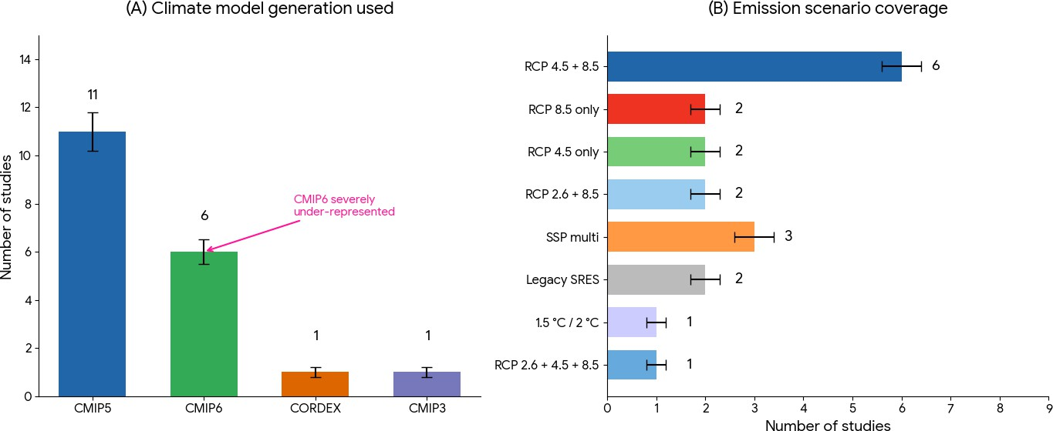
Figure S1. CMIP model generation and emission scenario coverage in the 18 projection studies. Left panel: proportion of studies using CMIP5, CMIP6, or both. Right panel: scenario distribution (RCP2.6, RCP4.5, RCP8.5, SSP1-2.6, SSP2-4.5, SSP3-7.0, SSP5-8.5).
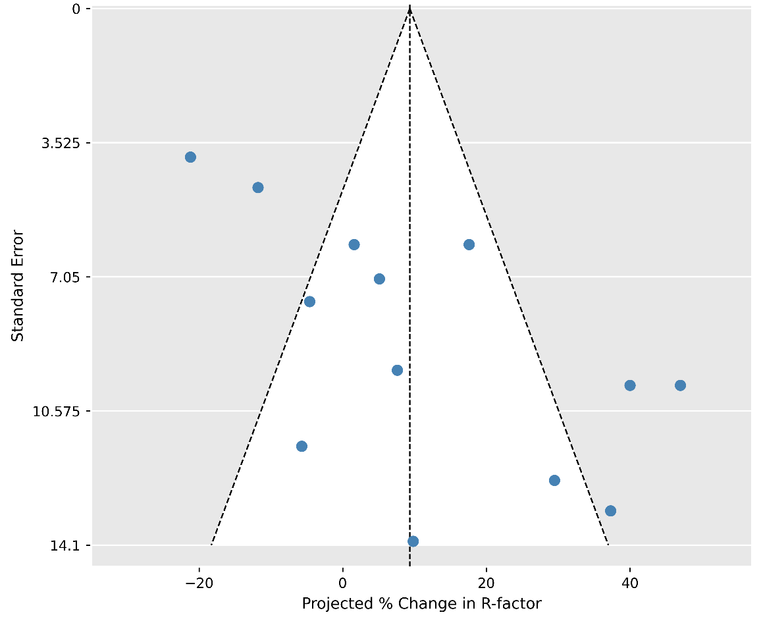

Figure S2. Funnel plot with pseudo-confidence contours for the random-effects meta-analysis of projected percentage change in rainfall erosivity (k = 12), illustrating small-study effects in the projection literature

Figure S3: Regional data scarcity and monitoring gap profiles.

